**Software**

**Testing**

**Vitt Android Application**

**Group Members:**

**Abhinav Ralhan U101115FCS039**

**Antra Tripathi U101115FCS055**

**Ayushi Goel U101115FCS066**

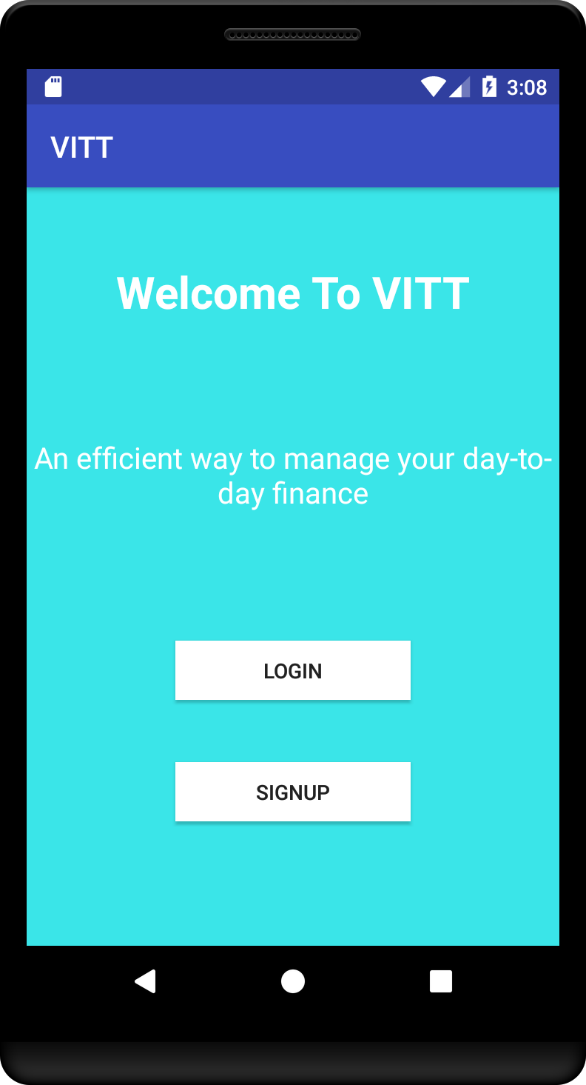

* **Expected Working:**

1. Figure shows the main screen (first boot up screen) of the application.
2. A maximum delay of 3 seconds is expected.

* **Behavior On testing:**

1. As expected the main screen comes immediately or max after 3 seconds.
2. The app closes normally on back press.

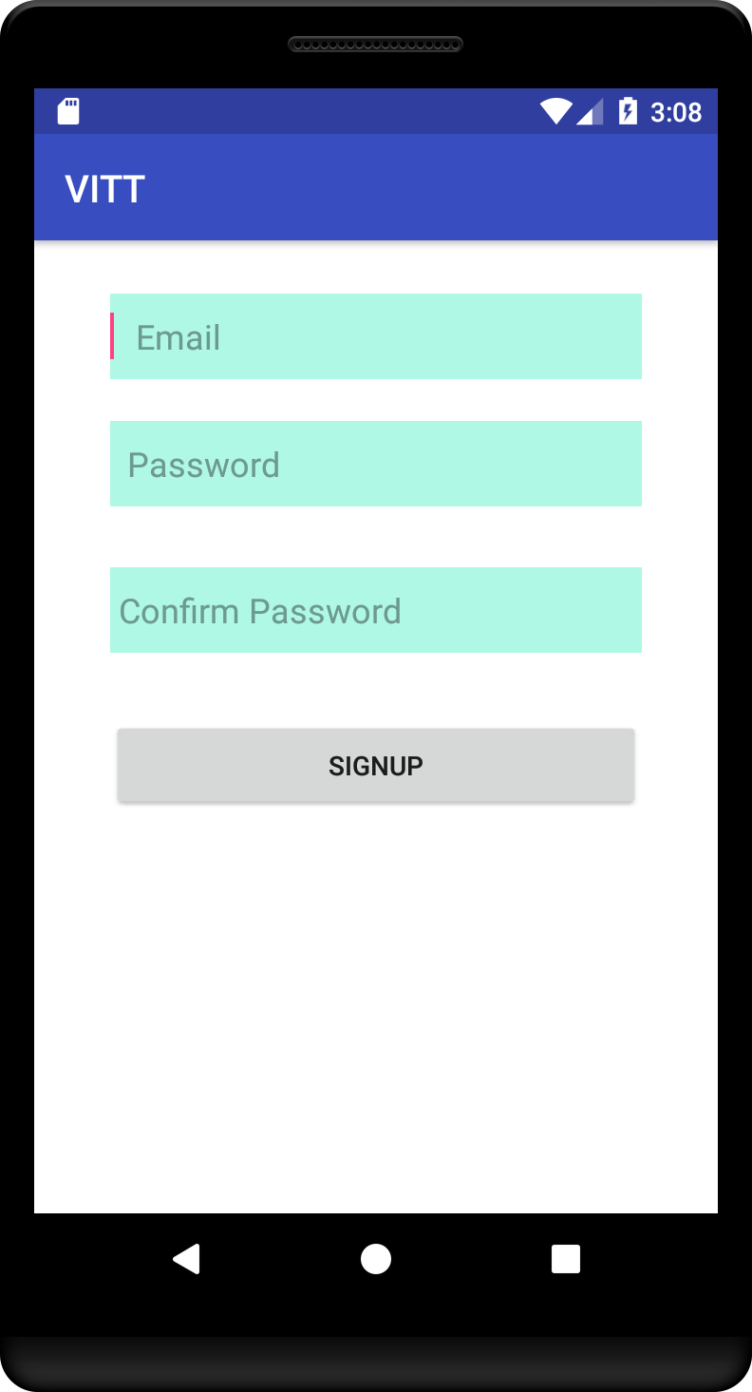 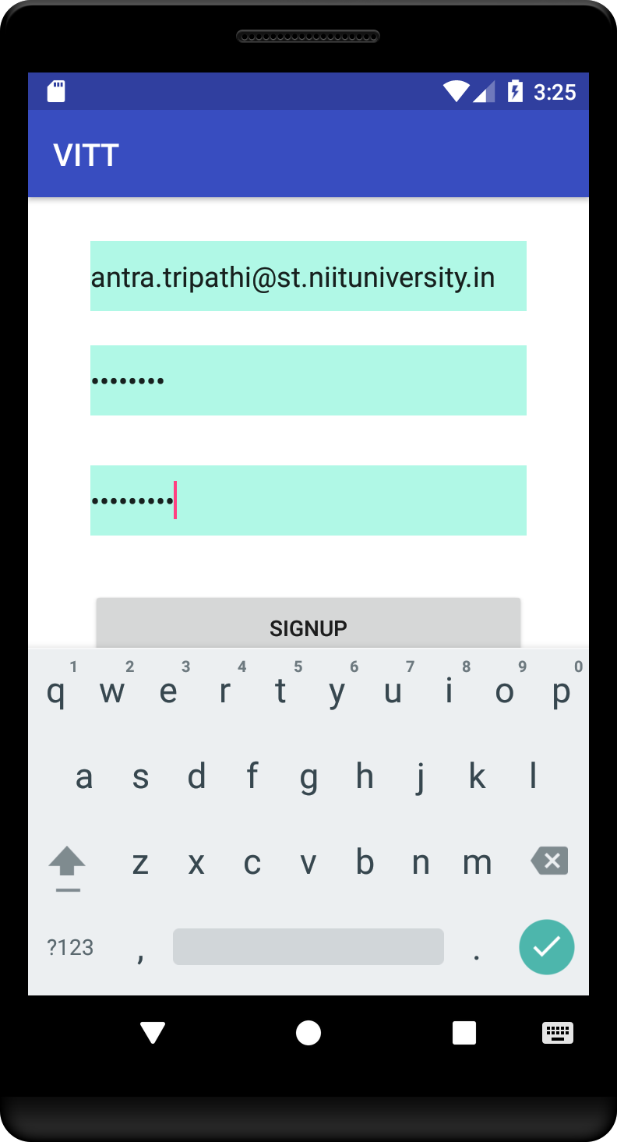

* **Expected Working:**

1. Figure shows the main sign up.
2. If the Email and Password fields are left blank, then an error pops

Up in the text boxes, and the login fails.

1. In case email and password fields are filled with valid text then there is no error.
2. User profile page appears.

* **Behavior On testing:**

1. As expected on leaving the email and password fields blank, we receive a red pop up error.
2. If the Email and password fields are filled up with valid type of data then there is no error.
3. The user profile page opens as expected.
4. The app closes normally on back press.

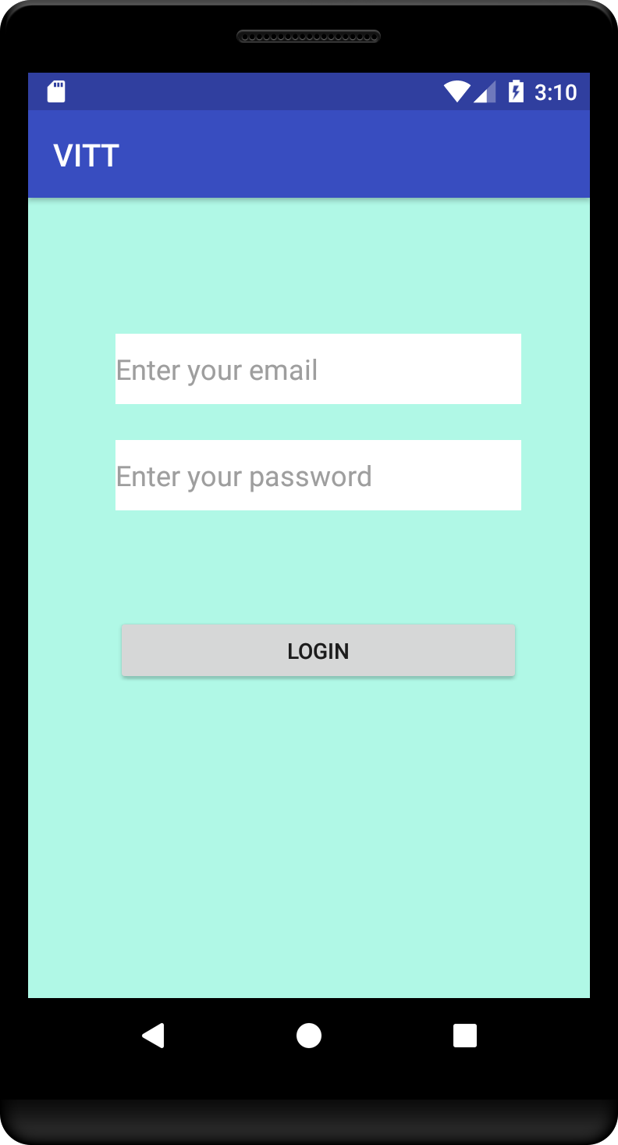 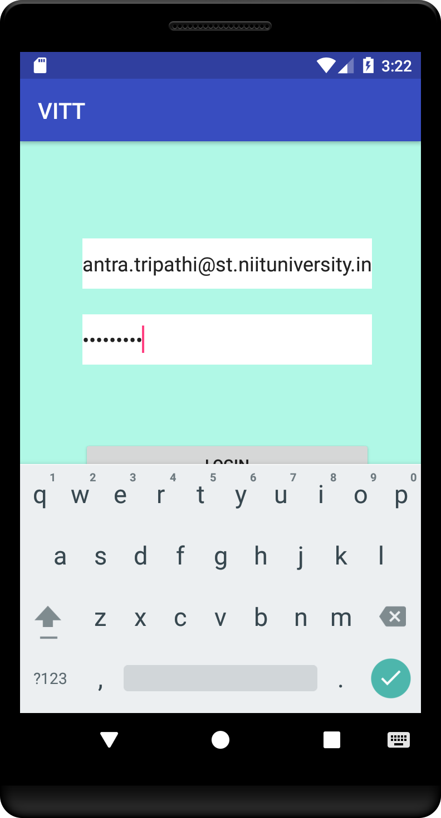

* **Expected Working:**

1. Figure shows the main log in page.
2. On entering valid, email id and password and clicking on the submit button, the request to login is processed on the Server

(Firebase).

1. In case email and password fields are filled with valid text then there is no error.

* **Behavior On testing:**

1. On entering valid email id and password, the user was logged in.
2. The user home page was loaded automatically as expected.
3. On back press, user is not logged out, until done manually

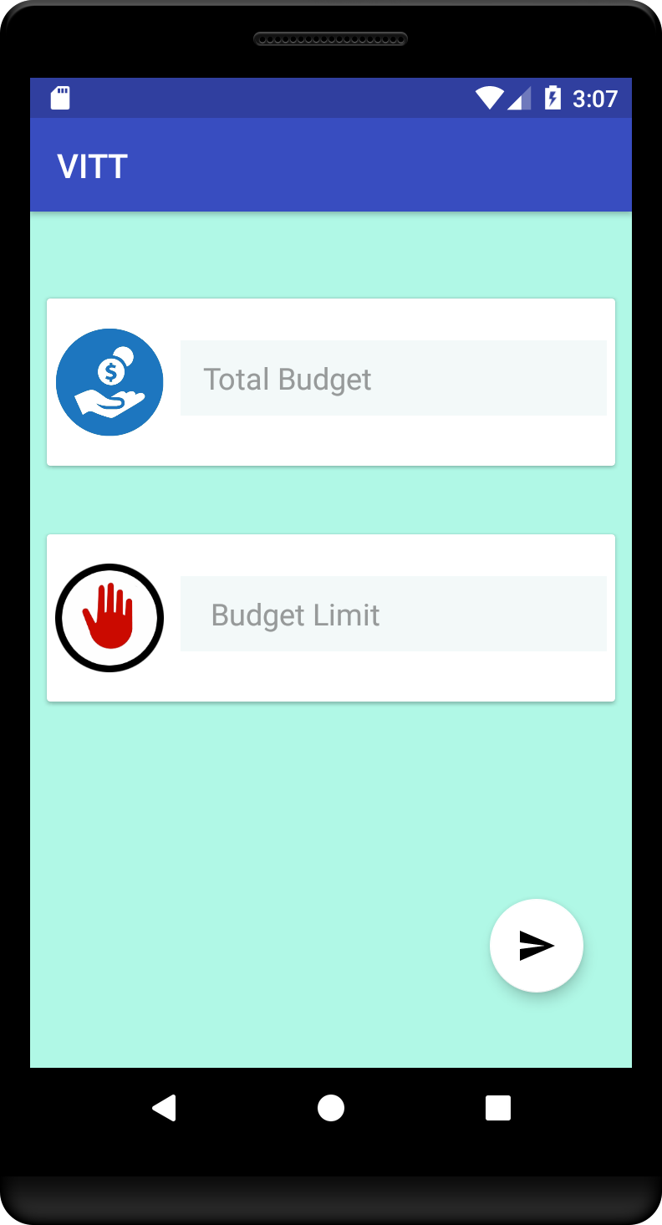 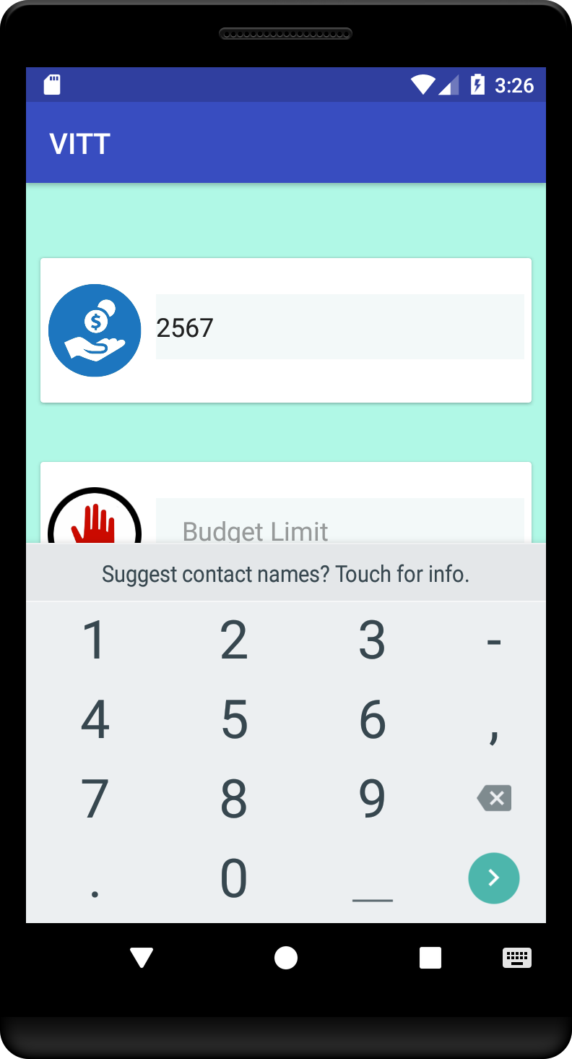

* **Expected Working:**

1. Figure shows main profile page.
2. On entering valid, values main screen is loaded.

* **Behavior On testing:**

1. On entering valid email id and password, the user was logged in.
2. The initial values are taken from user.
3. On back press, user is not logged out, until done manually

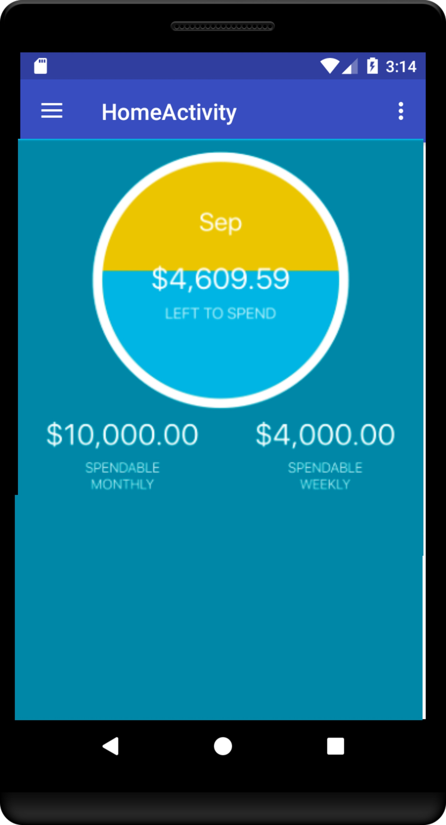

* **Expected Working:**

1. After Successful login, user home page must be displayed.
2. User can edit/update his or her profile by clicking on the ADD TRANSACTION button.

* **Behavior On testing:**

1. As expected, on clicking the ADD TRANSACTION button in home screen , it leads us to the adding screen

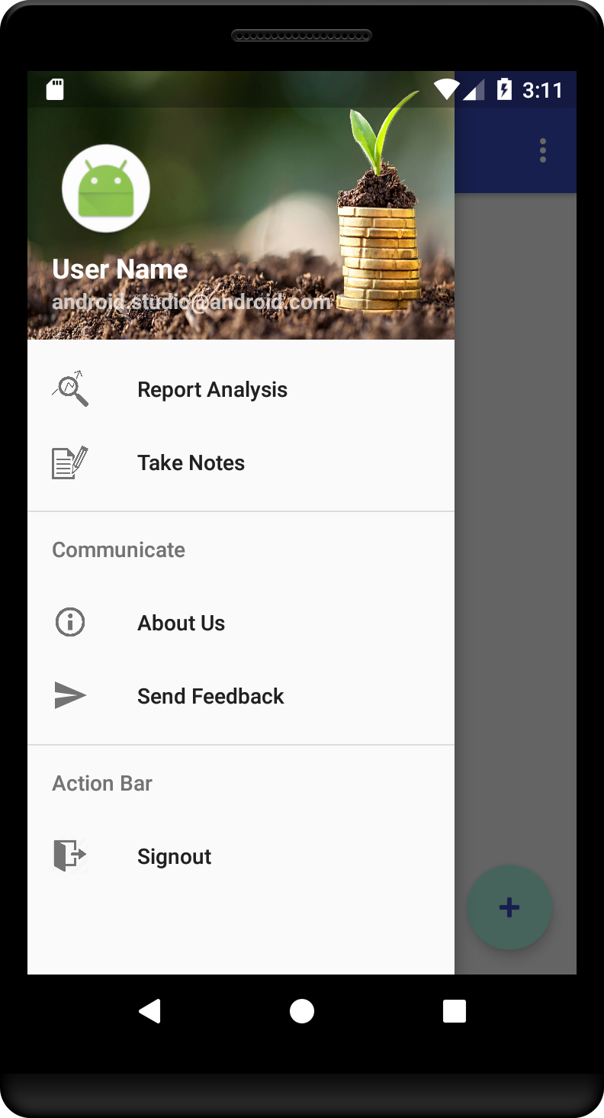

* **Expected Working:**

1. After the home screen, the navigator should open if the user clicks and should show 5 buttons to perform various functionalities.

* **Behavior On testing:**

1. As expected the navigator drawer opens up.

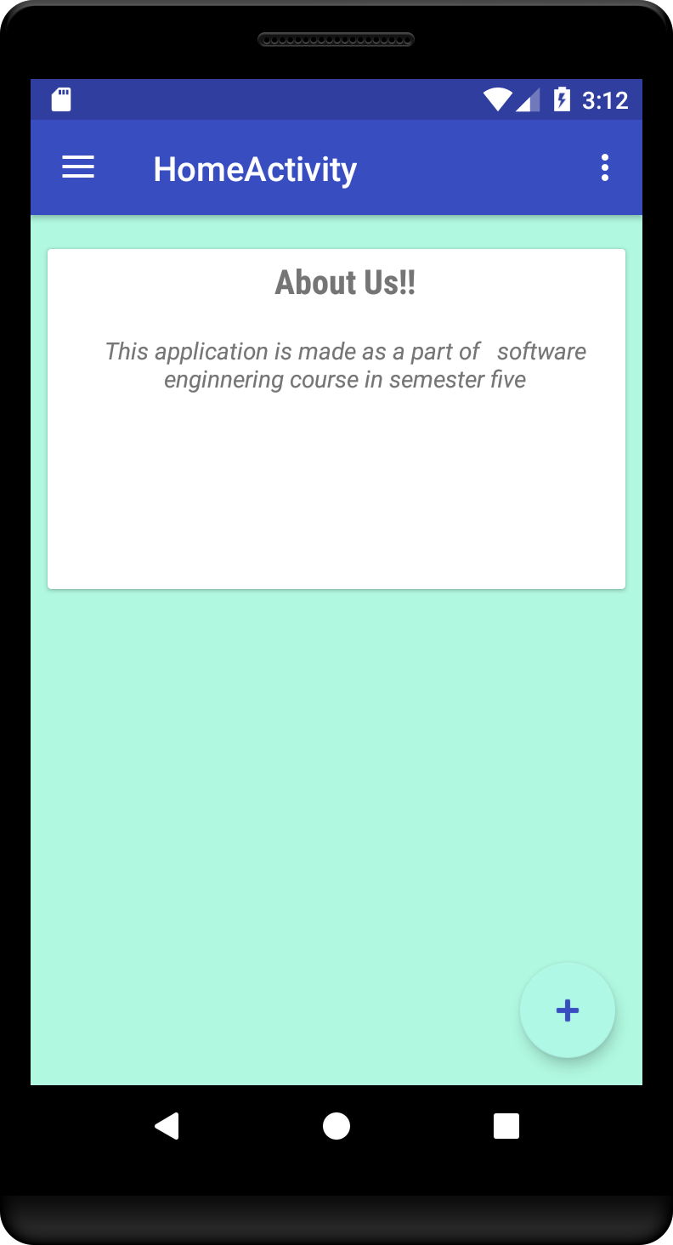

* **Expected Working:**

1. On clicking it should display information about app.

* **Behavior On testing:**

1. As expected all information is displayed.

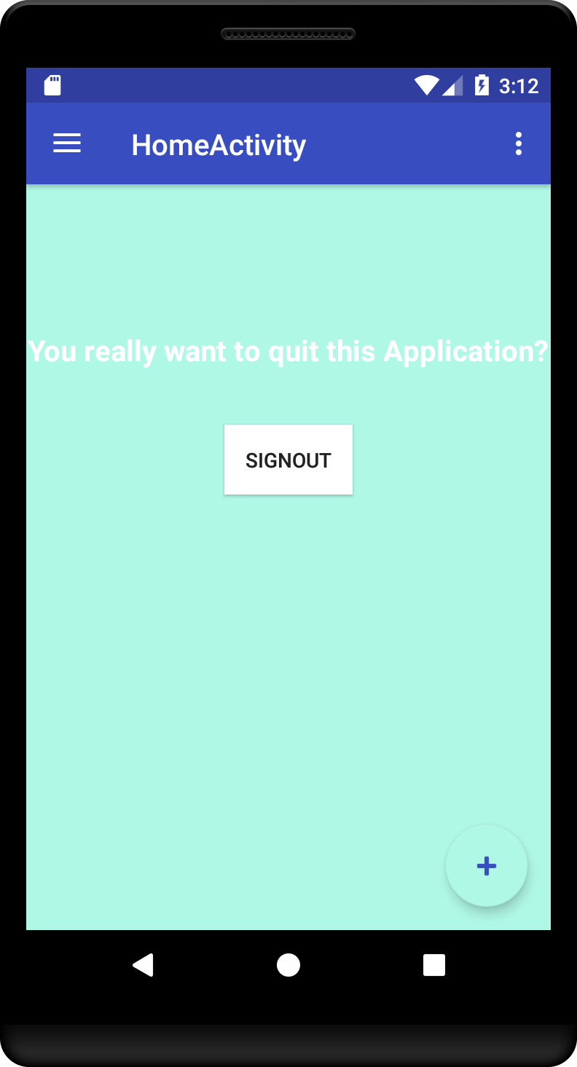

* **Expected Working:**

1. There is a Logout option in the menu as shown in Figure A.
2. Clicking the logout button leads us back to the login screen.

* **Behavior On testing:**

1. As expected, clicking on the logout button leads us back to the login screen.
2. On back press the app closes normally.

BELOW ARE THE SCREEMSHOTS OF THE WEB APPLICATION OF THE SAME APP:

